## 4.6 Goods Receive Process

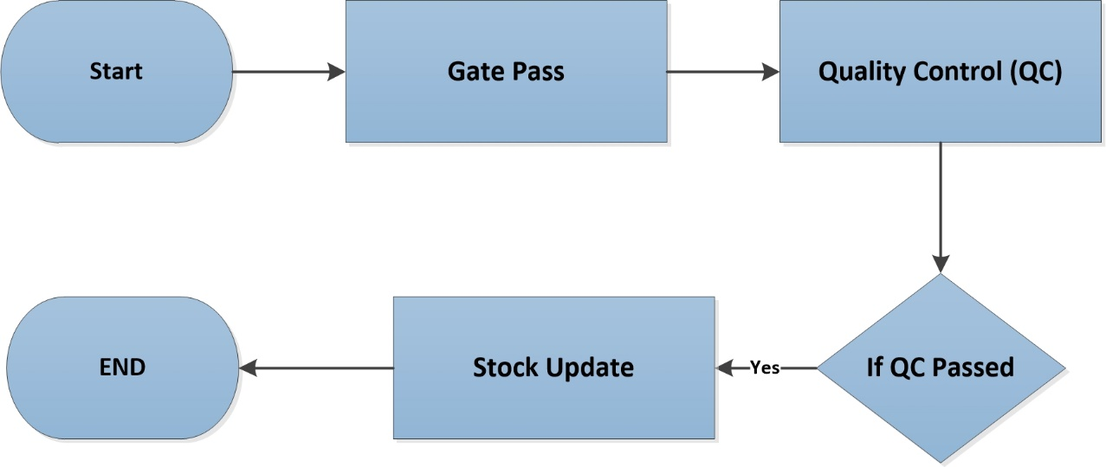

**Fig:** Goods Receive Process

### 4.6.1 Process Flow Description

* 1. Industry receives all goods by preparing a Material Receiving Repot (MRR).
  2. In MRR, customer includes all product description with quantity, purchase order no., packing no. and vat if any.
  3. There is MRR approval hierarchy which is given below-

1. Quantity Receive by –> Sign & Designation
2. Received by -> Store Personnel
3. Approved by -> Plant-in-charge

d. After successful gate pass material will be sent for Quality Control (QC) process. If is passed in QC, inventory will update the stock.